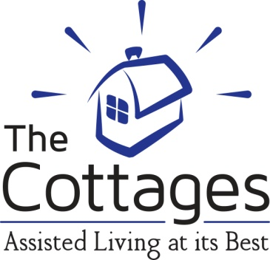

**Memory Care Training Module 2**

**Veteran’s Alzheimer’s and Dementia Training Disk #1 Answers**

1. Which is the most common type of dementia?
2. Vascular
3. Lewy Body
4. Alzheimer’s
5. This type of memory is usually the first to diminish:
6. Long term
7. Short term
8. Motor memory
9. Emotional memories can be built between staff and residents. True or False?
10. In Alzheimer’s residents, emotional memories often remain intact so it’s important to think about tone of voice and positive responses. True or False?
11. Three words to never say to a resident with dementia -- _ No You Can’t­­____.
12. Use ­­  props and pictures from the past as residents may be able to recognize these things as long term memory is often spared.
13. Residents with Alzheimer’s will miss one out of how many words spoken in the beginning stages of the disease?
14. 10
15. 2
16. 4
17. Eliminate the word Don’t from your daily interactions with residents.
18. Always Meet and Greet before approaching a resident to begin cares.
19. Give 2 examples of social chit chat:

Hello, how are you? It’s a nice day.___________________________________________

Many social chit chat answers are acceptable__________________________________