

**AutoArchive for Outlook 2007**

*AutoArchive is turned on by default in Outlook 2007 and will actually remove some of the oldest files (you determine the amount of time) completely. Recommendation: 30 days*

1) Open **Outlook**2) Click on **Tools** > **Options**

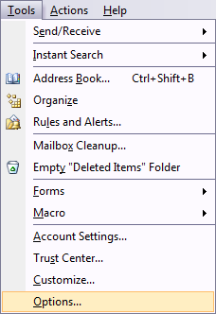

3) Click on the **Other** tab and click the **AutoArchive** button.

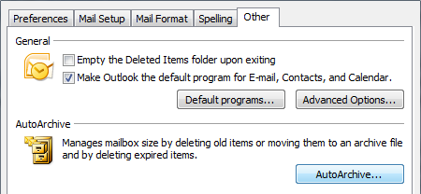

*This opens up a whole menu of options and settings to pick from: for instance you can choose how often AutoArchive runs.*

*4) Select 30 days; also place a check next to “****Prompt before AutoArchive runs****”*

*“Prompt before AutoArchive runs” is good to have selected just in case there is something you do not want removed from server. AutoArchive can also take some time so you might want to wait to do this task until you are away from computer.*

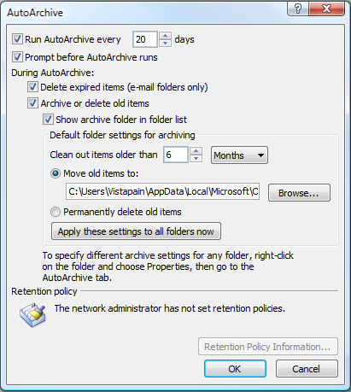

*This dialog window is also where you decide how old of files to clean out and the location to move them to. It will create a .PST file to store all of these items. Of course you can always select to permanently delete old items if you do not want to keep them around any longer.*

5) Click **OK** and your settings are saved

*Archiving old emails is a good way to help keep a nice clean mailbox, help speed up your Outlook experience, and save space on the email server. The other nice thing is you can configure your email archives and specific folders to meet your email needs. Please let me know if you need help.*