

**AutoArchive for Outlook 2010**

*Please archive your inbox, folders, and deleted items; set it up for every 30 days.*

In Outlook 2010 Auto Archive is not enabled by default.

To turn it on:

1) Click on the **File** tab

2) Click on **Options**.

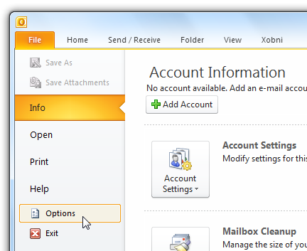

3) After Outlook Options window opens, click **Advanced**, then **AutoArchive** **Settings** button.

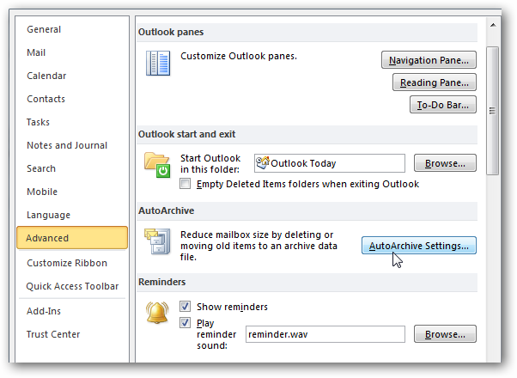

*The AutoArchive window opens and you’ll notice everything is grayed out.*

4) Check the box next to **Run AutoArchive every 30 days**

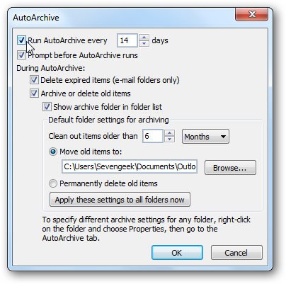

*Now you can choose the settings for how you want to manage the AutoArchive feature. Select how often you want it to run, prompt before the feature runs, where to move items, and other actions you want to happen during the process.*

5) After you’ve made your selections click **OK**.

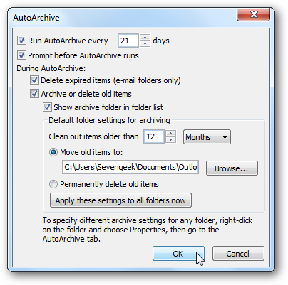

6) If you need to access your old e-mail, you can access them by clicking the **File** tab \ **Open** then **Open** **Outlook** **Data** **File**.

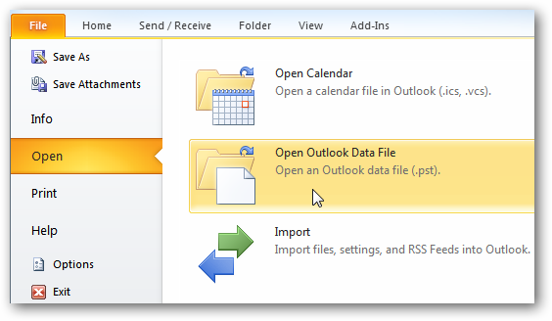

7) Browse to the archived file you want to open.

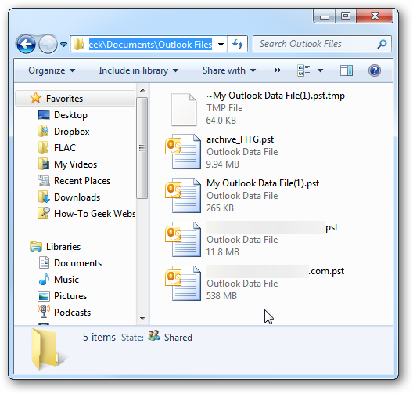

*Archiving old emails is a good way to help keep a nice clean mailbox, help speed up your Outlook experience, and save space on the email server. The other nice thing is you can configure your email archives and specific folders to meet your email needs*