

**AutoArchive for Outlook 2013**

*If you’re doing a little folder cleaning, you can manually archive messages. For example, you might be wrapping up a work project and need to put all the email messages associated with it into an archive file.*

*To manually archive messages, follow these steps:*

1. Click the **File** tab.
2. Click **Info**.
3. Click **Cleanup** **Tools**

[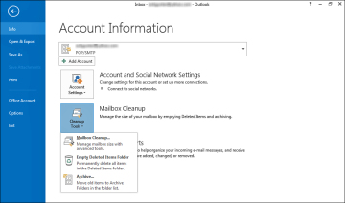](javascript:popUp('/content/images/chap5_9780789750914/elementLinks/05fig16_alt.jpg'))

1. Click **Archive** to open the Archive dialog box

[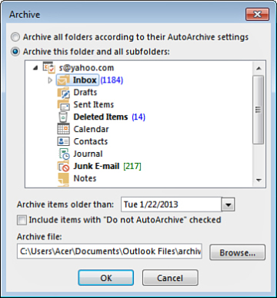](javascript:popUp('/content/images/chap5_9780789750914/elementLinks/05fig17_alt.jpg'))

1. Click the folder you want to archive.
2. Choose a cutoff date, such as items older than 6 months.
3. Choose an archive file location (click the **Browse** button, navigate to the location, and specify a more descriptive filename), or use the default filename and locations.
4. Click **OK**, and Outlook archives the messages.

**Setting Up Automatic Archiving**

*You can instruct Outlook to perform automatic archiving for you. You can set automatic archiving for individual folders or the Inbox in general.*  
*To set up automatic archiving, follow these steps:*

1. Select the folder or subfolder you want to archive, such as your Inbox or an old project folder.
2. Click the **Folder** tab.
3. Click the **AutoArchive** **Settings** button.
4. Outlook opens the Junk E-mail Properties dialog box to the AutoArchive tab of tools. Click **Archive** **this** **folder using these settings option.**

[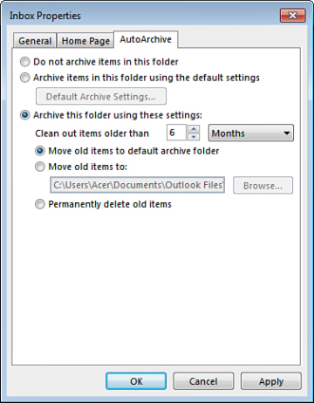](javascript:popUp('/content/images/chap5_9780789750914/elementLinks/05fig18_alt.jpg'))

1. Specify the age of the messages, such as older than 3 months.
2. Specify a location for the archived file, or use the default location.
3. Click **OK**.

*Each folder can have its own archiving settings, which is handy if you don’t want some folders tampered with, but others are good to square away.*